training 1 epoch...

81.10812902450562 seconds used......

1 training finished! average train loss: 0.7540598424662531

evaluating...

Confusion matrix, without normalization

[[ 24 16 50]

[ 2 30 35]

[ 6 13 325]]

Normalized confusion matrix

[[0.26666667 0.17777778 0.55555556]

[0.02985075 0.44776119 0.52238806]

[0.01744186 0.0377907 0.94476744]]

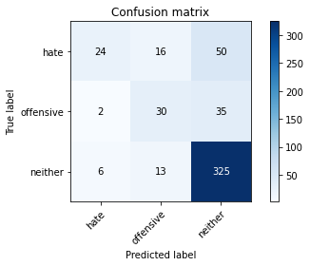

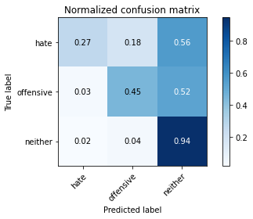

precision recall f1-score support

hate 0.75 0.27 0.39 90

offensive 0.51 0.45 0.48 67

neither 0.79 0.94 0.86 344

accuracy 0.76 501

macro avg 0.68 0.55 0.58 501

weighted avg 0.75 0.76 0.73 501

average eval_loss: 0.6283320979430125, accuracy: 0.7564870259481038

training 2 epoch...

88.27149319648743 seconds used......

2 training finished! average train loss: 0.5140343173942735

evaluating...

Confusion matrix, without normalization

[[ 50 13 27]

[ 14 28 25]

[ 19 20 305]]

Normalized confusion matrix

[[0.55555556 0.14444444 0.3 ]

[0.20895522 0.41791045 0.37313433]

[0.05523256 0.05813953 0.88662791]]

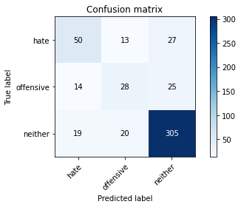

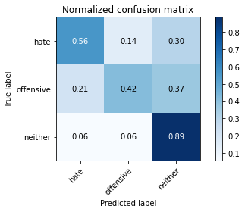

precision recall f1-score support

hate 0.60 0.56 0.58 90

offensive 0.46 0.42 0.44 67

neither 0.85 0.89 0.87 344

accuracy 0.76 501

macro avg 0.64 0.62 0.63 501

weighted avg 0.76 0.76 0.76 501

average eval_loss: 0.5673544567364913, accuracy: 0.7644710578842315

training 3 epoch...

87.9928069114685 seconds used......

3 training finished! average train loss: 0.31639426648287117

evaluating...

Confusion matrix, without normalization

[[ 63 2 25]

[ 20 28 19]

[ 35 11 298]]

Normalized confusion matrix

[[0.7 0.02222222 0.27777778]

[0.29850746 0.41791045 0.28358209]

[0.10174419 0.03197674 0.86627907]]

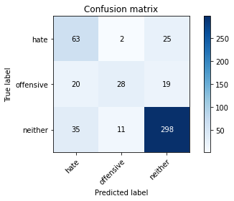

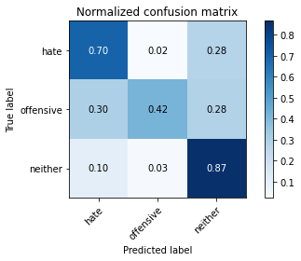

precision recall f1-score support

hate 0.53 0.70 0.61 90

offensive 0.68 0.42 0.52 67

neither 0.87 0.87 0.87 344

accuracy 0.78 501

macro avg 0.70 0.66 0.66 501

weighted avg 0.79 0.78 0.77 501

average eval_loss: 0.5856148954122685, accuracy: 0.7764471057884231

training 4 epoch...

87.96315360069275 seconds used......

4 training finished! average train loss: 0.15123747535610357

evaluating...

Confusion matrix, without normalization

[[ 46 14 30]

[ 5 42 20]

[ 14 22 308]]

Normalized confusion matrix

[[0.51111111 0.15555556 0.33333333]

[0.07462687 0.62686567 0.29850746]

[0.04069767 0.06395349 0.89534884]]

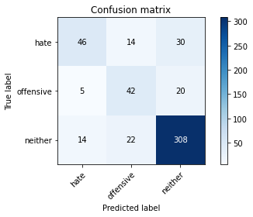

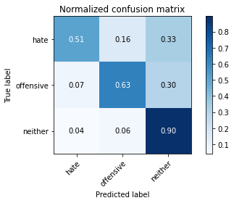

precision recall f1-score support

hate 0.71 0.51 0.59 90

offensive 0.54 0.63 0.58 67

neither 0.86 0.90 0.88 344

accuracy 0.79 501

macro avg 0.70 0.68 0.68 501

weighted avg 0.79 0.79 0.79 501

average eval_loss: 0.6484909315353994, accuracy: 0.7904191616766467

training 5 epoch...

87.98360538482666 seconds used......

5 training finished! average train loss: 0.06595823475555311

evaluating...

Confusion matrix, without normalization

[[ 63 3 24]

[ 14 34 19]

[ 36 9 299]]

Normalized confusion matrix

[[0.7 0.03333333 0.26666667]

[0.20895522 0.50746269 0.28358209]

[0.10465116 0.02616279 0.86918605]]

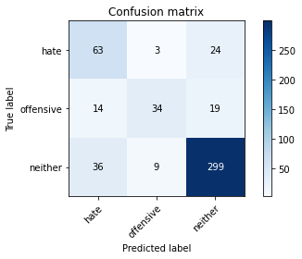

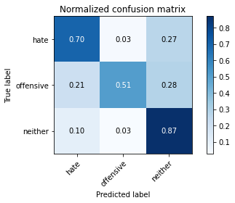

precision recall f1-score support

hate 0.56 0.70 0.62 90

offensive 0.74 0.51 0.60 67

neither 0.87 0.87 0.87 344

accuracy 0.79 501

macro avg 0.72 0.69 0.70 501

weighted avg 0.80 0.79 0.79 501

average eval_loss: 0.827694063862929, accuracy: 0.7904191616766467

Confusion matrix, without normalization

[[ 382 71 320]

[ 98 163 169]

[ 207 105 2017]]

Normalized confusion matrix

[[0.49417853 0.09184994 0.41397154]

[0.22790698 0.37906977 0.39302326]

[0.08887935 0.04508373 0.86603693]]

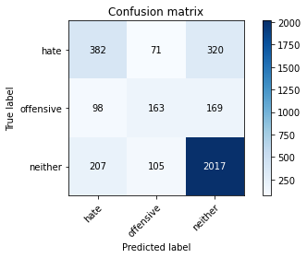

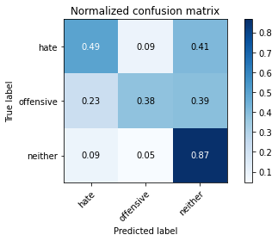

precision recall f1-score support

hate 0.56 0.49 0.52 773

offensive 0.48 0.38 0.42 430

neither 0.80 0.87 0.83 2329

accuracy 0.73 3532

macro avg 0.61 0.58 0.59 3532

weighted avg 0.71 0.73 0.72 3532

average eval_loss: 1.1682014404717138, accuracy: 0.7253680634201586

0.7253680634201586